**Advanced Safety Helmet For Workers**

Mrunal Jadhav1, Niraj Mistri1, Akansha Pole1, Arti Tekade1, Vijayalaxmi Kumbhar1, Maithili Andhare1

1Dept. of Electronics and Telecommunication Engineering, Pimpri Chinchwad College of Engineering and Research Ravet , Maharashtra, India

*E-mail:* mrunalrjadhav06@gmail.com

Abstract - Mining is world's most dangerous professions. In some nations, underground miners lack safety and social protection, be left to fend for themselves if injured. Additionally, there are adverse societal repercussions, including displacement and loss of livelihood. Mining has the greatest fatality rate of any industry. The most workplace fatalities poisoning, and electrocution. There are various case studies regarding underground mines; for example, a recent case study in China indicated that underground mining is the world's deadliest business. disasters, we developed a more advanced communication technology that must work in tandem with an intelligent sensing and warning system. The most critical component in every business is safety. are paramount in the mining business. To avoid mishaps, the mining sector takes various safety precautions .

***Keywords:* Internet of Things (IOT), Wi-Fi, Cloud Think Speak, Python 8.**

1. Introduction

In whatever form of construction, worker safety should always be a primary priority. Underground mining operations are a high-risk attempt in terms of worker safety and health. The diverse procedures utilized to harvest various minerals are to blame for these hazards. The deeper the mine, the higher the risk [1][2][3]. These worries about safety are especially severe in the coal industry. As a result, worker safety should be a major priority as safety for various kind of mining, coal or any other types of minerals. Underground coal mining is more dangerous than open pit mining due to ventilation concerns and the possibility of collapse [4][5][6][7].

The use of heavy machinery and excavation procedures, pose safety dangers in all types of mining. Modern mines routinely adopt a wide range of safety protocols, worker education and training, and health and safety requirements, resulting in substantial modifications and improvements in both opencast and underground mining [8][9][10]. Coal India's principal and it has played rapid industrial development. Coal provides for around 70% of power generation, making its significance in the energy sector essential. However, additional byproducts of represent a possible the people involved. Instead, the current effort is a genuine attempt to analyze gravity real-time detection monitoring WIFI technology [11][12].

An IoT has attracted the researchers attention for various industrial and commercial application such as society automation, agricultural field monitoring, smart city, smart bracelets for the women, smart water quality management, industrial automation, robotics and control, etc. It provides the connectivity over the internet for more than billions of devices that can be used for remote controlled monitoring [13][14][15].

This paper presents, The temperature sensor, heartbeat sensor, smoke sensor, buzzer, WIFI module. Sensors will read the values and send it to the controller. If the conditions of environment changes like if smoke at the workers end increases system send alert. Hence our system is helpful for the worker.

.

This paper is organized as follow: Section 1 delivers the introduction of the worker safety helmet. Section 2 provides literature survey of various smart helmets. Section 3 describes the objective specifications. Section 4 describes the methodology used with the help of block diagram. Section 5 gives us the expected model and flowchart of the project. Section 6 provides results. Section 7 depicts use of project like applications. Section 8 elaborates the advantages of the project. Section 9 gives future scope. Finally, section 10 provides conclusion as well as reference papers.

1. Literature Survey

Astana et al. [16] presented the project, which is based on a real-time detection and to keep under surveillance system for sewage levels, aims to provide intelligent solutions for observing harmful sewage gases. When a predefined approach is exceeded, an alert is delivered to a remote observer who is monitoring the situation. The data is subsequently transmitted, with discrete gas ppm levels recommending either it is safe for the worker to clean as well as to work in that environment. The proposed system contains remote-monitoring IoT devices as well as an IoT platform. This includes calibrating industrial gas sensors and establishing suitable septic plant and facility threshold levels. If harmful gaseous elements in the system grows over time, the hardware is meant to send an alarm to the worker, ensuring their safety. Numerous types of sensors sewage elements such as gas, temperature, and so on. When the approach value is less than the sensed values, this system notifies the worker via SMS & phone call. By observing various toxic gases and then calculating their results for real-time executing , this system works in the prevention of dangerous diseases and also prevents a social cause. Sensor sample values were gathered the proposed system. Carbon monoxide and methane sensors detected levels exceeding the 2.3 and 60 parts per million (ppm) thresholds, respectively, and a GSM module is used to send an alert to the cell phone entered into the code .

Freeman et al.[17] One of the issues that developing-country water distribution businesses encounter is discovering and reporting leaks on time. The study defines a nature inspired search approach for favourable locations for the water leakage sites. The nature stimulate technology supports in representing IoT edge computing devices used by water and sewage employees to discover and locate leaky pipelines. Specially in cities and urban areas. When worker is indicated by a cause from any area indicating leaks, the program generates location data that spontaneously processes.. In the research paper given a system which is nature inspired system based on the performance of a Kestrel bird is used as the representation .The system is tested and assessed to predefined and randomly generated sites. According to the data, the suggested KSA, which was applied as a representation function, it was victorious in giving the prototypical distance after collecting water leaking geographic position data from IoT edge computing devices.

Haswani et al.[18] Drainage system that removes water sewage or other dangerous types of liquids from a location, and its state should be checked on a regular basis to guarantee effective drainage performance. Manually monitoring all regions where a human cannot reach is difficult, however it is quite challenging. Hence it contributes to the blocking of underground pipelines, and water overflows are the source of the health problem. To solve all of these problems, we designed and built a system based on a wireless sensor network. It is made up of data gathering devices. These sensing devices are known as nodes. The suggested system is a low cost, low preservation, long lasting, freely available real-time system that sends text messages to municipal officers when any manhole reaches a specified threshold value. The health of workers who clean underground drainage is directly impacted by this system. It also reduces mosquito borne illness transmission, maintains a clean and healthy atmosphere, and regulates diseases such as, dengue fever, malaria and diarrhea. The system reduces the impact of an open manhole.

Tian et al.[19] As the global industry grows, sewage treatment is becoming increasingly crucial. The sewage farm's terrible atmosphere, on the other hand, poses a plethora of problems for the wireless system. This research presents a measuring and control system based on a wire-free Mesh network to address the issue. In this system, we created a sensor node based on the AT89C2051 and nRF2401, it can collect the necessary local data to finish sewage therapy and to keep under surveillance the machine's power to escape an injury in the absence of a cable. The findings of the experiments reveal that this measuring and controlling system can be automate the sewage treatment process while also monitoring system performance and worker convenience.

Amirhossein et al.[13] During wastewater processing, sewage treatment plant (STP) operators are open to a range of dangers. The purpose control these hazards utilizing an in a Malaysian STP (OSHMS). Initially, data on reported dangers were acquired through a study of literature, the distribution of questionnaires, and expert interviews. Based on the conditions of the chosen STP, the most dangerous dangers were recognized. The dangers were then listed in terms of security and likelihood. The biggest worries of site workers, according to the research, are noise, skin discomfort, slip and fall. As a result, noise cancelling devices were deployed to lessen noise. The usage of carpet and cardboard lowered the existing noise level (94.2 db.) to 92.1 dB and 90.6 db., respectively. It is proposed that an auto-cleaner, self-cleaning bar screen, and sharp-pointed blades be installed at the area to limit the danger of skin irritation. Furthermore, cordoning off sections for cleaning and providing incline at the cleaning area around the cleaner have been deemed to adequate solutions for the slip and fall risk at the site. A new infectious disease has been discovered in the Chinese region of Wuhan.

1. Objectives

The objectives of the proposed work are summarized as follow:

1. In every business, the most important factor is safety. Safety is one of the important factors in the mining industry.
2. Our major goal is to prevent any type of mining accident.
3. To avoid the conditions of environment changes.
4. To maintain security is a fundamental aspect of all.
5. To avoid accidents of workers working in mining industries.
6. Proposed Methodology

As shown in Fig no. 1 i.e., Block Diagram Safety is the most critical part of every industry. The mining business prioritizes safety and security. To avoid any form of accident, the mining sector takes several fundamental safeguards. Accidents continue to occur in underground mines as a result of rising temperatures, rising water levels, and methane gas leakage. Here, we ensure worker safety.

If a worker is in danger, he can call security by pressing the panic button. To increase underground mine safety, a reliable communication system between subterranean mine workers and the fixed ground mining system must be built. At no time or under any circumstances should the communication network be disrupted. This concept proposes a low- cost wireless mine surveillance system based on IOT.

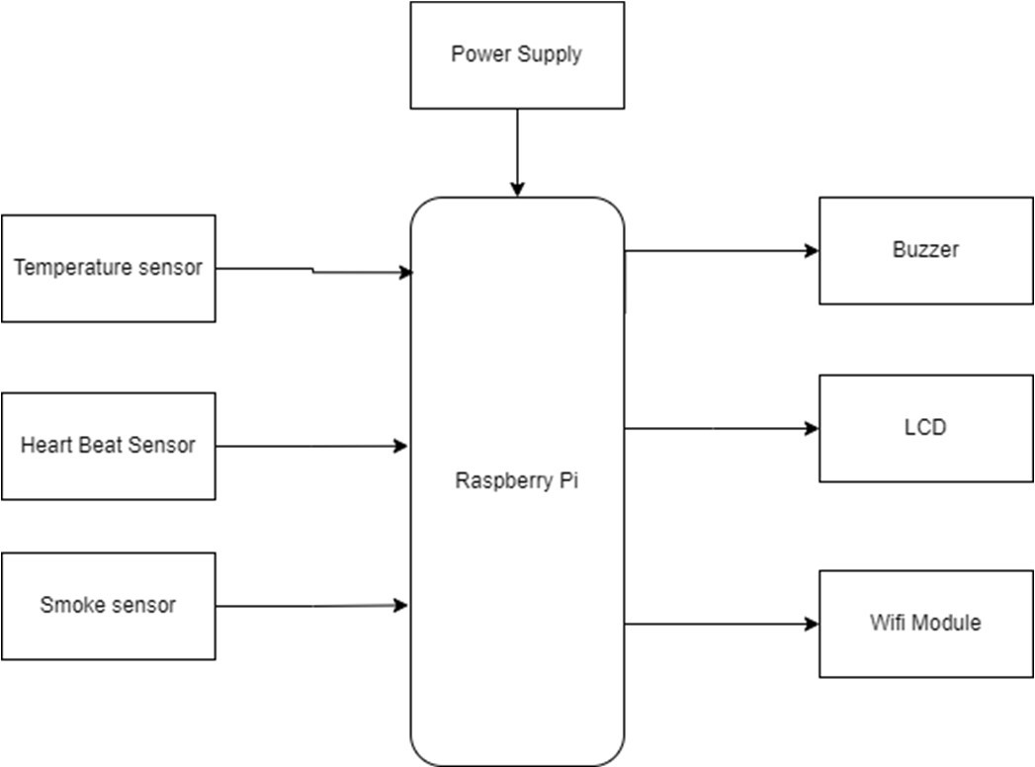

Fig. no.1 Block Diagram

1. Expected Model

As shown in Fig no 2 The dangerous gases are sensed using gas sensors. Every time the poisonous gas is sensed the control valve gets opened for providing oxygen companion.

In this project the raspberry pi is the major controller. The system is able to monitor the health conditions of the worker as well as surrounding conditions. Also, if the worker health disturbed system will send the alert message.

In the system temperature sensor, heartbeat sensor, smoke sensor, buzzer, WIFI module is used. Sensors will read the values and send it to the controller. If the conditions of environment changes like if smoke at the workers end increases system send alert. Hence our system is helpful for the worker.

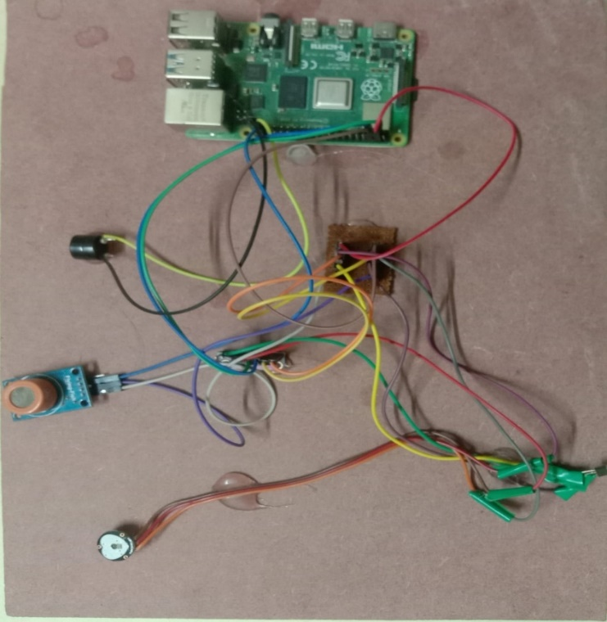

Fig No. 2 Model

Flowchart

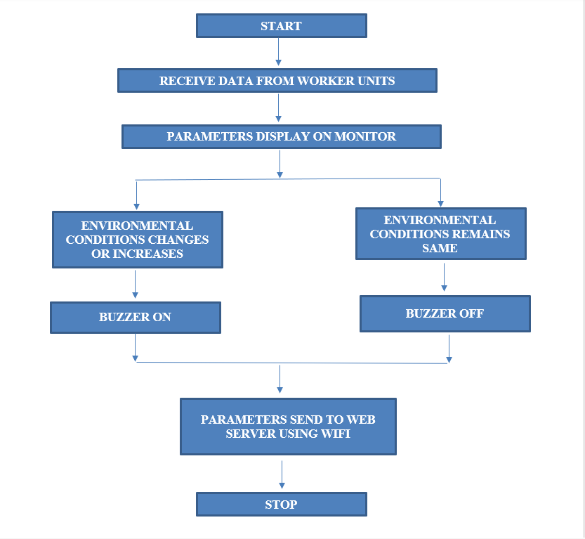

Fig No. 3 Flowchart

1. Results

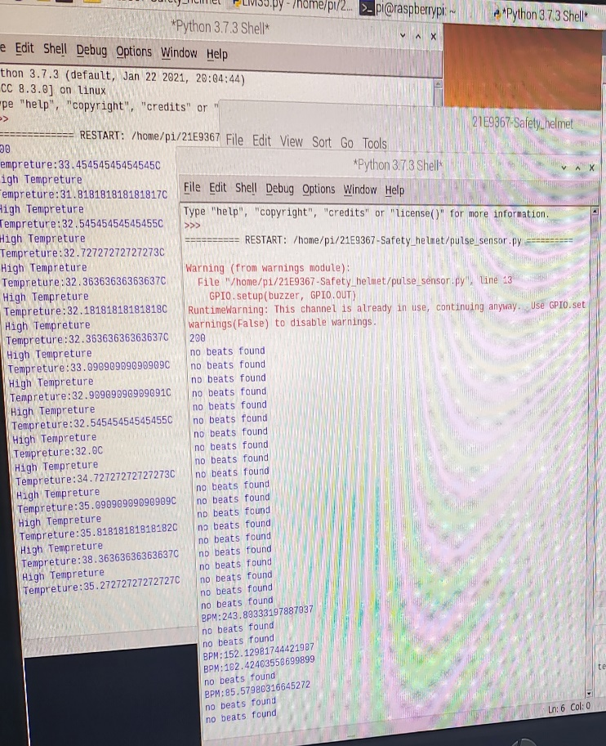

Fig. No. 4 Result for temperature sensor and heartrate sensor

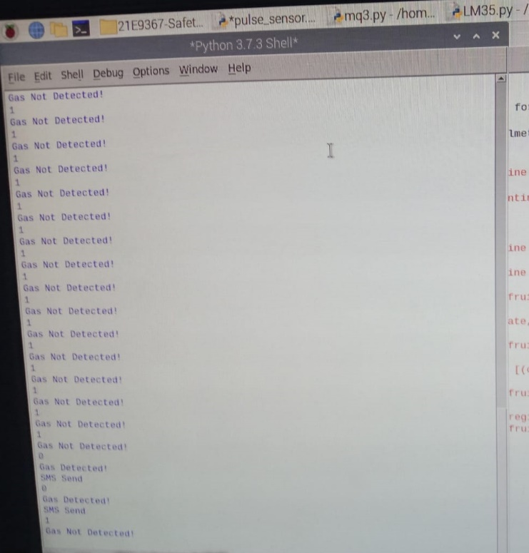

Fig. No. 5 Result for gas sensor

In the above Fig No. 4 and Fig no. 5 the results are shown with the help of python software, where the conditions are applied in the code. If the purposed system satisfies the condition the results will be displayed on the screen .

1. Advantages

* Secure miners’ safety in case of mining accidents that occurs due to environmental changes i.e., increase in temperature, leakage of dangerous gases, increase in heart rate of the worker.
* To communicate the coal miners inside the mines with the outside world.
* To keep surveillance on the conditions inside the mines and alert the miners in case of emergency crisis.
* Alerting the miners in case the helmet is take off.

1. Applications
   * Mining industries
   * Construction sites
   * Disaster prevention
   * Rescue request
   * Police services
2. Future Scope

* To avoid the range issues, we can attach a Signal/network Catcher.
* For better communication Walkie Talky can be added.
* To date, there has been in-sufficient research on the security and privacy of data collected by smart helmets through sensors. It can be improved to maintain the privacy of data collection.
* Small Fans Can be added.

1. Conclusion

The proposed methodology aids in both the prevention of workplace accidents and the preservation of society's cleanliness. The smart safety gadget is less expensive and more quickly connects and transmits data to emergency department. Therefore, a smart helmet for detecting dangerous environmental conditions, monitoring workers heartrate and antique the information and the sensed data with the help of sensors to the control main unit for easy tracking and providing oxygen supplements to avoid the inhalation of hazardous gases is intended.

References

1. Chang A.Y, Chang-Sung Yu, Sheng-Zhilin Lin-Yeh Chang, Pei-Chi Ho, ‘Search, Identification and Positioning of the Underground Manhole with RFID Ground Tag’ INC, IMS and IDC, 2009. NCM ’09.Fifth International Joint Conference on vol no. pp.1899, 1903 25-27 Aug.2009.
2. M. Maroti, B. Kusy, G. Simon, and A. Ledeczi, “The flooding time synchronization protocol,” in Proc. ACM SenSys’04, Baltimore, MD, November 2004.
3. Wemer Allen, G., Johnson, J., Ruize, M., Less, J., and Welsh, Matt ‘Monitoring Volcanic Eruptions with a Wireless sensor Network’. Proceedings of 2nd European Workshop on Wireless Sensor Network, 2005.
4. ZigBee Alliance, “Understanding ZigBee gateway”, ZigBee Document 095465r13, September 2010.
5. Sobin, C. C. "A survey on architecture, protocols and challenges in IoT." *Wireless Personal Communications* 112, no. 3 (2020): 1383-1429.
6. Malakahmad, A., Downe, A.G. and Fadzil, S.D.M., 2012, April. Application of occupational health and safety management system at sewage treatment plants. In 2012 IEEE Business, Engineering & Industrial Applications Colloquium (BEIAC) (pp. 347-350). IEEE.
7. Zhou, Mudi, Zhuli Fang, Bin Zhao, and Pengfei Li. "Safety Helmet Wearing Detection and Recognition Based on YOLOv4." In 2021 3rd International Academic Exchange Conference on Science and Technology Innovation (IAECST), pp. 798-802. IEEE, 2021.
8. Gao, Yumin, Yan Liu, Daojin Nie, Ziming Huang, Bin Li, and Bing Qian. "An Efficient Safety Helmet Detection based on Attentional Mechanism." In 2021 7th International Symposium on System and Software Reliability (ISSSR), pp. 97-98. IEEE, 2021.
9. Ren, Dacong, Tongsheng Sun, Cungui Yu, and Cheng Zhou. "Research on Safety Helmet Detection for Construction Site." In 2021 International Conference on Computer Information Science and Artificial Intelligence (CISAI), pp. 186-189. IEEE, 2021.
10. Sharma, Susanta, Allumallu Veera Venkata Susmitha, Lan-Da Van, and Yu-Chee Tseng. "An Edge-Controlled Outdoor Autonomous UAV for Colorwise Safety Helmet Detection and Counting of Workers in Construction Sites." In 2021 IEEE 94th Vehicular Technology Conference (VTC2021-Fall), pp. 1-5. IEEE, 2021.
11. Biradar, Priya, Priyanka Kolsure, Sujata Khodaskar, and Kishor B. Bhangale. "IoT based smart bracelet for women security." *Int. J. Res. Appl. Sci. Eng. Technol.(IJRASET)* 8, no. 11 (2020): 688-691.
12. Sarraf, Rajan, Shalini Ojha, Damini Biraris, and Kishor B. Bhangale. "IoT based smart quality water management system." *International Journal* Of Advance Scientific Research And Engineering Trends, 5, no. 3 (2020).
13. Mapari, Rahul, Kishor Bhangale, Laukik Deshmukh, Prashant Gode, and Ankit Gaikwad. "Agriculture Protection from Animals Using Smart Scarecrow System." In *Soft Computing for Security Applications*, pp. 539-551. Springer, Singapore, 2022.
14. Kun Han ,Deep Learning-Based Workers Safety Helmet Wearing Detection on Construction Sites Using Multi-Scale Features Published in: IEEE Access ( Volume: 10) Page(s): 718 – 729, 2021.
15. Huang, Li, Qiaobo Fu, Meiling He, Du Jiang, and Zhiqiang Hao. "Detection algorithm of safety helmet wearing based on deep learning." *Concurrency and Computation: Practice and Experience* 33, no. 13 (2021): e6234.
16. Asthana, Nitin, and Ridhima Bahl. "IoT device for sewage gas monitoring and alert system." In *2019 1st International Conference on Innovations in Information and Communication Technology (ICIICT)*, pp. 1-7. IEEE, 2019.
17. Freeman, Emmanuel, Daniel Ayitey Quaye, Israel Edem Agbehadji, and Richard C. Millham. "Nature-inspired search method for IoT-based water leakage location detection system." In 2019 International Conference on Mechatronics, Remote Sensing, Information Systems and Industrial Information Technologies (ICMRSISIIT), vol. 1, pp. 1-8. IEEE, 2020.
18. Haswani, Navin G., and Pramod J. Deore. "Web-based realtime underground drainage or sewage monitoring system using wireless sensor networks." In 2018 Fourth International Conference on Computing Communication Control and Automation (ICCUBEA), pp. 1-5. IEEE, 2018.
19. Tian, J., Wu, H. and Gao, M., 2008, April. Measurement and control system of sewage treatment based on wireless sensor networks. In 2008 IEEE International Conference on Industrial Technology (pp. 1-4). IEEE.

**Plagiarism Report**

